Buenos Aires Herald

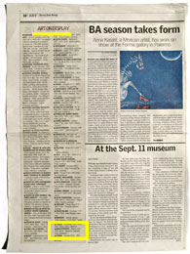

Art on display
Week January 20 to 26, 2008
MASOTTATORES - Mexico 459 / 4331 6078 - Macarena Gagliardi, video installation.

